**Full Stack Engineer**

Assignments

Cognizant Technology Solutions

*Projjwalanka Pramanick (299202)*

CSS Assignment 2

**CSS File**



**Profile Image**



**Navigation Page**

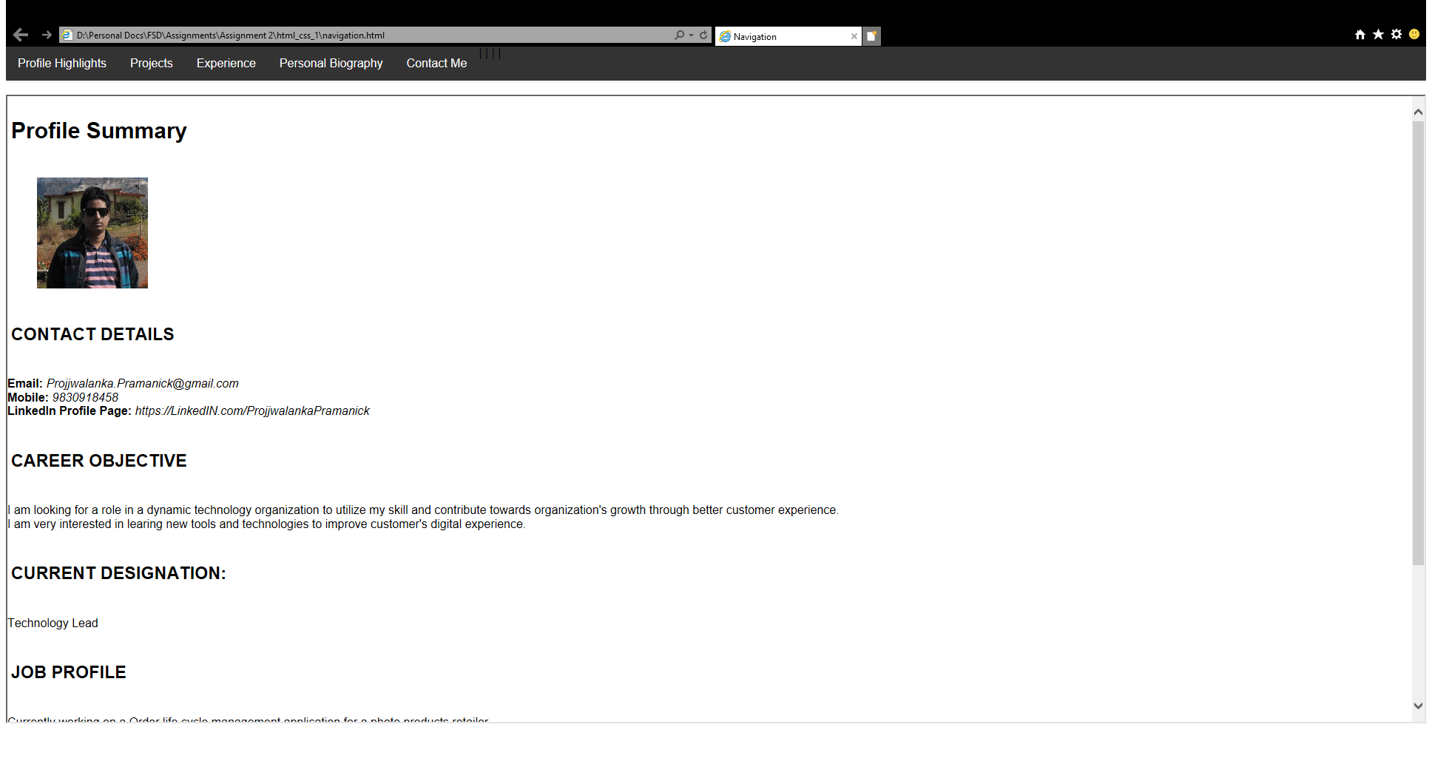



**Index**

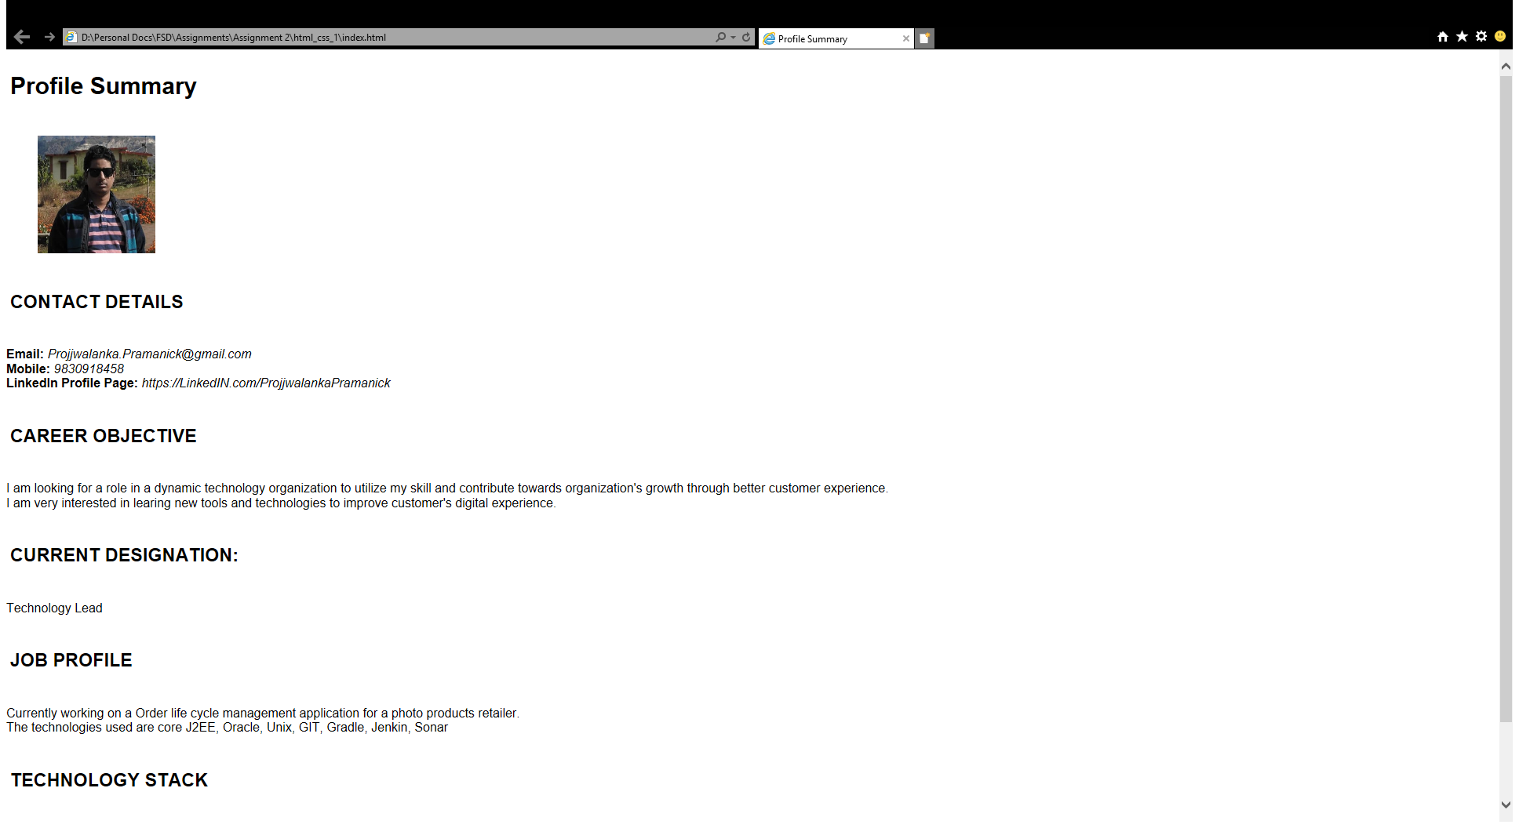



**Profile Highlights**

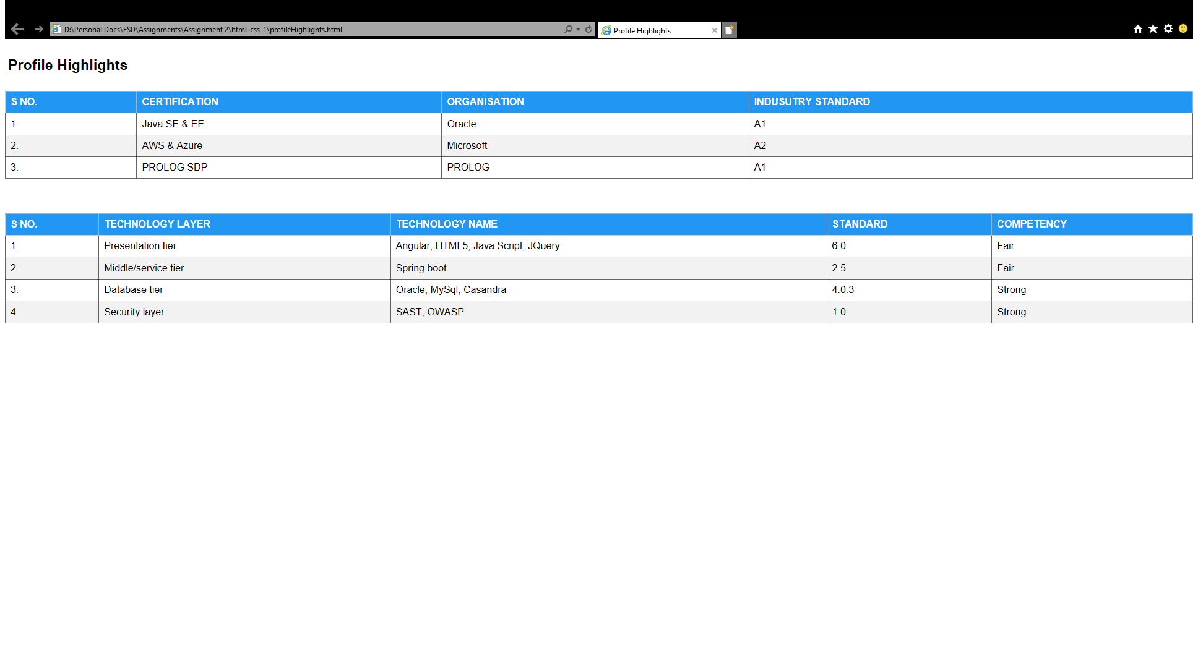



**Experience**

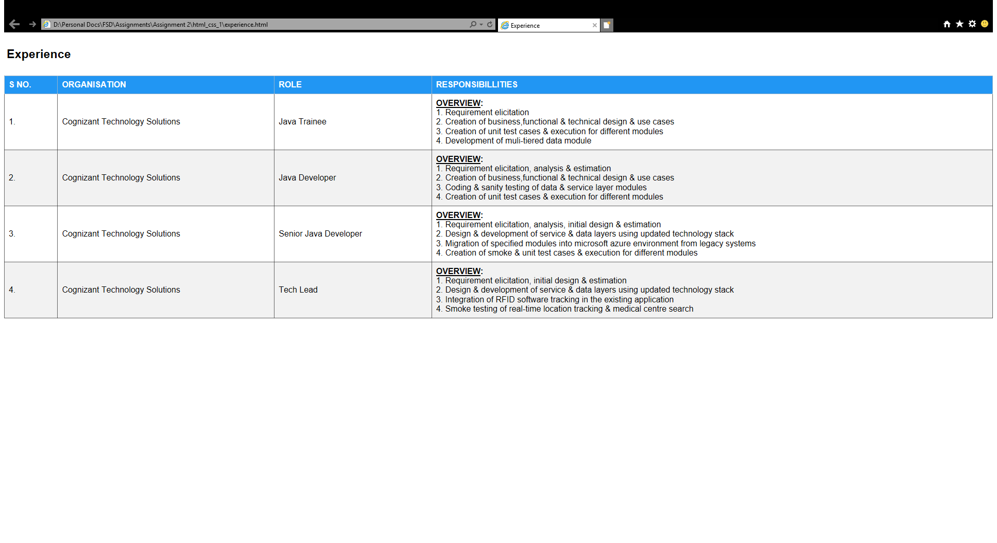



Personal Biography

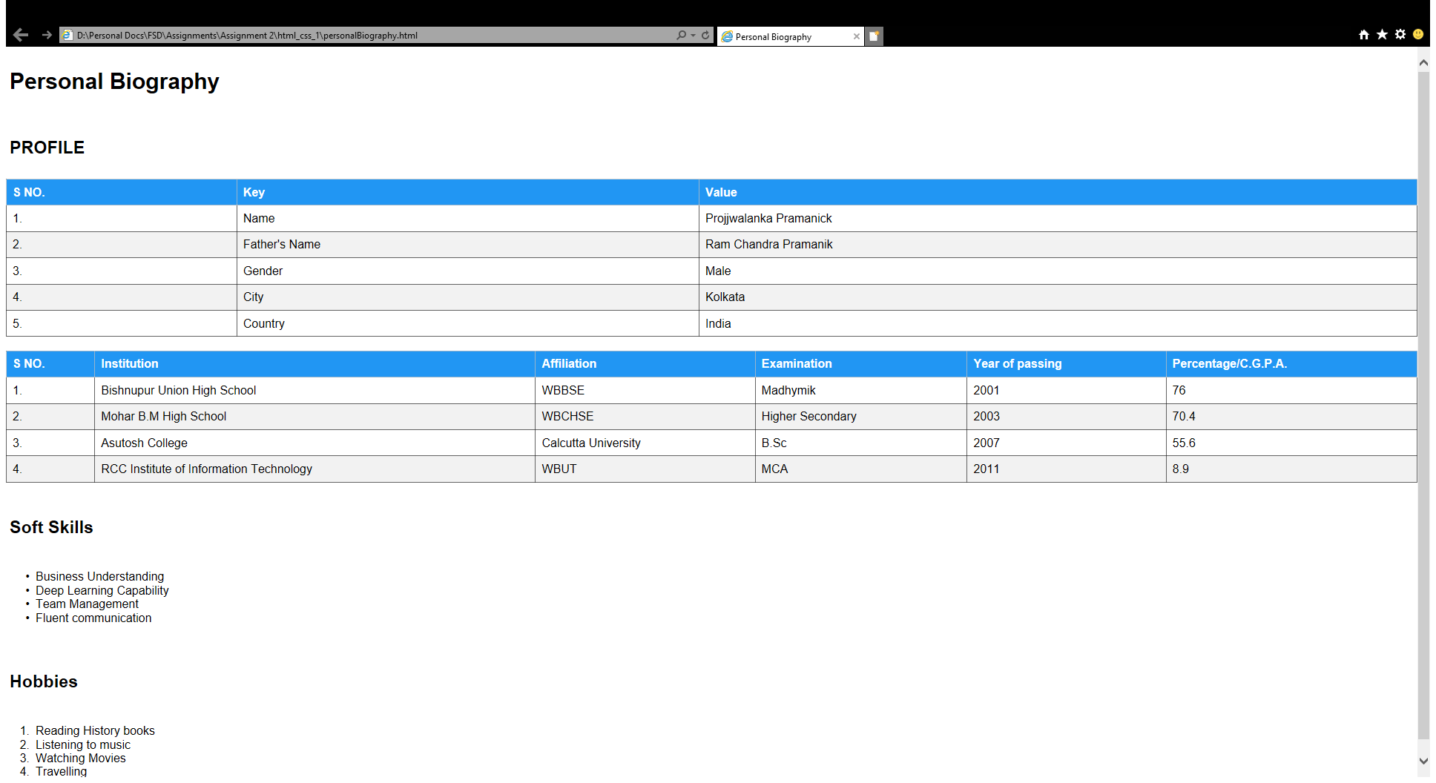



Projects

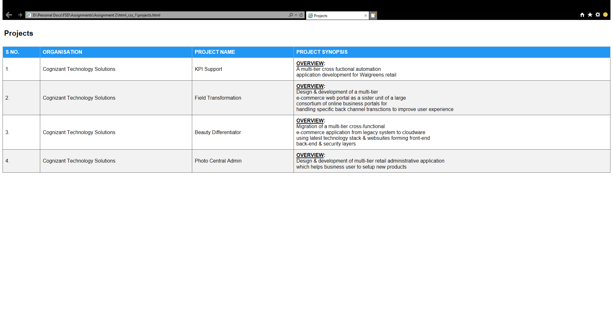



Contact Me



